Historical Antigen processing script.

Location: BC_Main\Database\agmgr\scripts\Process_Historical_Antigens.sql

Purpose: Use this script to process historical data related to antigens and populate the antigen tables. Note that it will be a case-to-case scenario based on the client’s existing data and design. Script will have to be customized as per the client’s requirements.

Pre-requisites:
- Antigen Manager feature should be enabled.
- Antigen manager-related configuration tables must be set up.

Script:

SET SERVEROUTPUT ON;

DECLARE
ld_start_date DATE := TO_DATE('01-01-2014', 'MM-DD-YYYY');
ld_end_date DATE := TO_DATE('05-15-2024', 'MM-DD-YYYY');
ln_increment_months NUMBER := 12;
lv_status VARCHAR2(2000);
BEGIN
AG_CORE.handle_hist_antigens( ld_start_date,
ld_end_date,
ln_increment_months,
lv_status
);

DBMS_OUTPUT.PUT_LINE('Status ' || lv_status);
END;

Notes:
- Script takes three inputs. Start Date, End Date and Increment months parameters.
  - Start Date: Provide the start collection date for the historical data.
  - End Date: Provide the end collection date for the historical data.
  - Increment Months: Provide number of months for the script to process incrementally. Eg: 12 months increment indicates the script processes 1 year data at a time from start_date until the end_date is reached.
- Script generates a log file in the format ‘AG_CORE-HIST-051524152034.log’ at LOGDR location hat indicates the times used for processing.

Recommendations:

- Run the script with
  - Start date as the oldest collection date.
  - End date as start date + 2 years.
  - Increment months as 12.

- Check the log file to note the times. Use this as an estimate to figure out the time it will take for the script to run. If needed, adjust the input parameters to run it for short periods of time.

- Check the data after the initial run to make sure that the antigen tables data looks good.

Log File output (Attached log file screenshots):

- The header part shows the parameters used for the script and has some data metrics like the number of records processed, CPU time utilized for processing them.

- The detail part shows the time taken to insert into the job-queue table and the time taken for processing via AG_CORE pkg.

- Use the log file to estimate the time to process the historical data.

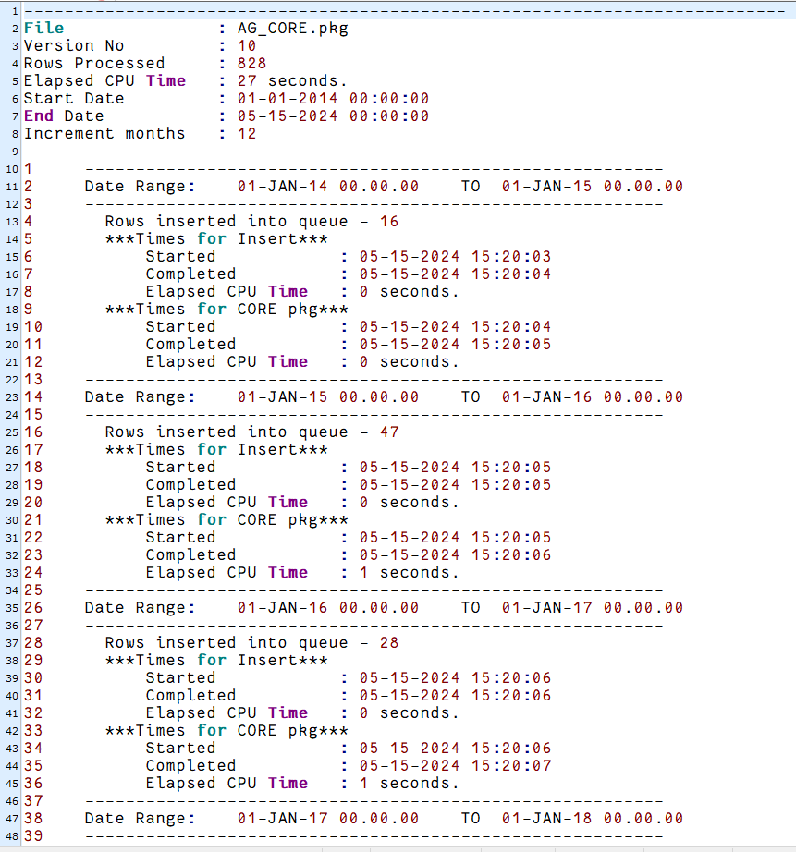
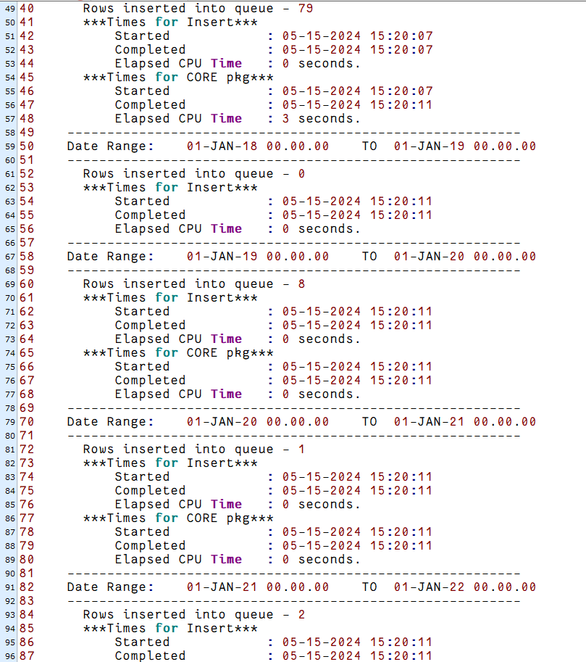

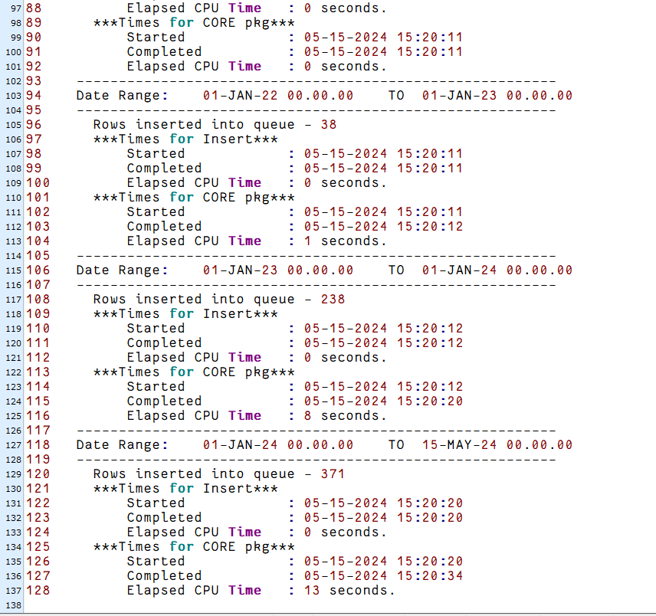

Version | Date | Comments
01 | 05/15/2024 | MLT-6276 (Script to process historical antigen data)

